Intro + Framing (Richard) (30 seconds)

* CV and fixed base approach
* Us primary stakeholders, not serving real clients, project details include features that are not really convenient for real car-owners
* Dfx’s
* Hand over

General design concept diverging (Leo) (30 seconds)

* Individual research + brainstorming
  + We individual did some online research on alternative designs, and came up with some ideas with individual brainstorming
  + Conventianal approaches
  + Some of our crazy ideas
* Meetup and discuss pros and cons
  + For general design concepts, not really possible to test them all
  + Used engineering judgment to converge on top of three using the listed pros and cons
* Convergent based on risk minimization
  + The cons listed for different alternatives illustrate the risks associated with each
  + We decided to converge upon the three more conventional designs since they have a lower risk
  + Our final result should be a different combination of these, since each one has its advantage and disadvantages.
* Final design based on a combination of three alternatives

Project timeline + Trello (Manqiu) (30 seconds)

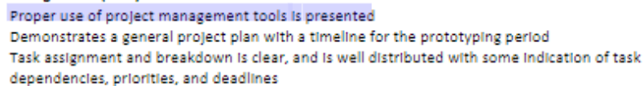

* Our team decided to use Trello for project management, mainly for task assignments and deadline reminders. Each task and deliverables are listed in order of due dates. Once we’ve finished with a task, we can check it off as completed.
* Tasks and deadlines are decided based on requirements from milestone.
* Task assignment is based on individual’s interests and strengths.

CAD designs (Leo +, Richard)

* Intro of choosing track as our first option (10s)
  + Most promising for stability and precision.
  + Test this approach this
  + CAD
* Bottom track (20s)
  + Demonstrated different axis of movement can be achieved by different linear motion techniques
  + Will test each technique further
  + Timing belt actuator
  + Rack and pinion actuator
* Upper holder (20s)
  + Two linear sliders on two sides responsible for z direction, powered by stepper motors
  + Servo motor attached under the charger holder for angle, insertion motion handed to the base
  + For the upper part, it is responsible for the z and angle degrees of freedom
  + In our conceptual prototype, there are two linear tracks responsible for lifting the charger holder up, and a rotation component for the angle
  + We are considering to add another linear track for the inserting motion
  + All other degrees of freedom are associated with the base

Algorithm (Manqiu) (30s)

* Mostly relies on computer vision to detect the location of the charging port.
* (Shows picture) One way is to use computer vision is to detect the circular port with its builtin function to detect circles. However we noticed that it’s not totally accurate.
* The angle of the car can be detected with simple pose estimation by sticking a grid on the car.
* (shows flowchart) Here is flowchart showing the general idea. Basically, the coordinate on the photo will inform the system to move in a certain direction. Either we use two cameras for depth detection or use the IR/Ultrasonic sensor.

Component Selection / Plan for Converging

* Actuator & Motor (30s)
  + Converged down to three options
  + cost and stability are the main concerns
  + 3D printing as much as of the linear track as possible, cheaper, more flexible, easier to test and verify our assumptions
  + (The plan to converge is to design different prototypes with 3D printing, and test the performance (reliability, accuracy, repeatability) for different axis of movement with a stepper motor and a dummy weight to fill in the blanks and verify the research we made.)
  + Stepper motor or servo motor because of its high precision and torque.
  + Will calculate the desire acceleration, RPM, torque requirement,
  + Look up motors with these specifications with in a feasible budget,
  + Test the device’s effectiveness after actual track is constructed

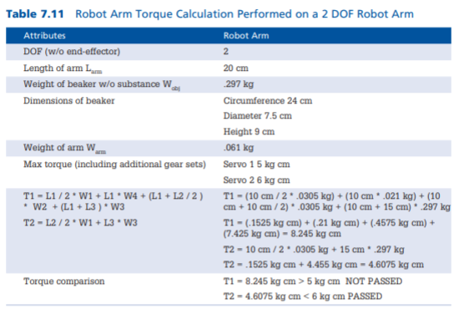

* Camera & sensor (20s)
  + Selection of cameras and sensors will be based off of online reviews and specs. However, it is still important to test them ourselves. For cheap sensors, we are likely to purchase them and decide which one is better mainly in terms of their resolutions and accuracy. For cameras, there are more online reviews, but it’s also important to test them with our algorithm to test its effectiveness in computer vision.
* Microcontroller (30s)
  + Microcontroller to mini-computer spectrum
  + Final selection needs to account for the cost and compatibility of all other components
  + Finally, for microcontrollers, its more like a spectrum we are considering
  + One end microcontroller such as Arduino, the other end is more like mini-computers
  + All of the design aspects are listed for consideration, the four alternatives
  + Pugh chart style, leaning towards raspberry pie
  + Plan to converge considering all other components

Conclusion